Carlin Vision
Final Package — SOP and Decision Trees
Aligned to Locked Scripts 1–19
Implementation manual mirroring the locked Call Center Scripts. This package contains the Standard Operating Procedures and Decision Trees. It is designed to be reviewed alongside the locked Scripts 1–19 file.
Prepared by: Carolina Clavijo, AI & Operations Consultant — Arthur De Gennaro & Associates LLC
Date: July 4, 2026
Status: Draft for Dr. Carlin Review — Near-Final
Authority: CV_Scripts_1to19_Combined_LOG_VERSION.docx is the master authority. Where any conflict existed, it was resolved in favor of the locked scripts.
Contents
- Section 1 — Standard Operating Procedures (SOP 1: Routine vs. Medical Scheduling · SOP 2: Triaging Medical Emergencies)
- Section 2 — Decision Trees (DT-1 through DT-4)
- Section 3 — Alignment Notes (summary of corrections made for script conformance)

SECTION 1 — STANDARD OPERATING PROCEDURES
These procedures govern how all Carlin Vision staff — physicians, call center, front desk, and technicians — schedule, communicate, and document patient visits. They mirror the operating logic of the locked Scripts 1–19. Where this document and the scripts describe the same step, the scripts control.
SOP 1 — Routine vs. Medical Scheduling
All Staff: Physicians, Call Center, Front Desk, Technicians
1. Purpose
This SOP establishes one shared standard across Carlin Vision so that all staff schedule, communicate, and document patient visits consistently and in a way that reflects the clinical and billing intent of each appointment type.
2. Scope
Applies to all inbound scheduling calls for new and returning patients, and informs physician and technician decisions when a visit type changes mid-appointment. All staff use the same definitions, language, and communication standards.
3. Definitions
These definitions are consistent with AAO and ASOA billing guidance and standard ophthalmology payer practice.
Routine Vision Exam
A visit whose chief reason is wellness or vision care only: checking eye health, updating a glasses or contact lens prescription, or a routine recall with no active symptoms, known eye disease, or disease follow-up. Billed to the vision plan.
Medical Eye Exam
A visit whose chief complaint involves eye symptoms, trauma, a known or suspected eye disease, or disease follow-up. The physician's evaluation addresses medical necessity. Billed to medical insurance.
Refraction
The portion of an exam that determines the glasses or contact lens prescription. Refraction is a separate patient charge, is not included in medical exam billing, and is not automatically covered by medical insurance. Patients are informed of this before or at check-in.
New Patient / Returning Patient
New patient: new to Carlin Vision. Returning patient: previously seen here — chart history, recall notes, and prior visit type inform scheduling, and known diagnoses must be checked before routing. Use patient-friendly language ("Have you been seen here at Carlin Vision before?"), never clinical terminology.
Urgent Symptoms — Exit to SOP 2
Any sudden or concerning change: acute vision loss or blur, eye trauma, flashes, new or worsening floaters, painful red eye, headache with vision change, change in pupil size, or swollen eyelid with pain. These exit SOP 1 immediately.
4. Core Standards
- Chief complaint drives the scheduling decision — not the patient's insurance preference.
- Urgency comes first. If urgent symptoms are present, follow SOP 2 before determining visit type.
- Doctor selection happens after the routing decision, not before it. Staff classify the visit from the chief complaint and screening first, then select the doctor within the chosen script path — matching the locked scripts.
- Insurance is collected after classification, doctor selection, and demographics — the final step before scheduling confirmation. Both vision and medical insurance are collected on every call.
- Physician has final authority to classify the visit based on medical necessity and clinical findings.
- Schedulers are not diagnosing. They apply a decision framework. When unclear, escalate to the technician or clinician on duty — never guess.
5. Scheduling Rules
5.1 Standard Routing
- Chief reason is glasses, refraction, or a routine eye check, and the patient denies symptoms and known eye disease after screening → routine vision exam (Script 1).
- Patient reports any symptom, trauma, known eye disease, or disease follow-up → medical eye exam (Script 2).
- Any urgent symptom is present → exit SOP 1 and follow SOP 2 immediately (Scripts 4–8).
5.2 Age-Based Blur Rule
✅ Age rule is 55 or older, confirmed by Dr. Carlin, June 11, 2026. All prior references to age 50 are superseded. Quick reference for 2026: patients born in 1971 or earlier are 55 or older; update this cutoff year every January.
- Under 55, gradual isolated blur, no symptoms, no known disease, onset more than one week → may schedule as routine. Staff must still screen for symptoms before classifying.
- Age 55 or older with blurred vision → schedule as medical eye exam (Script 3 language). Ocular pathology is more likely at this age and a medical evaluation is required to rule out underlying causes.
- Any blurred vision with sudden onset, pain, flashes, floaters, field defect, double vision, or trauma → follow SOP 2 regardless of age.
5.3 Handoff Rule — SOP 1 to SOP 2
Precise handoff point: any blurred vision with onset less than one week, or accompanied by pain, flashes, floaters, field defect, double vision, or trauma. Stop and follow SOP 2 immediately.
5.4 Returning Patients with Known Diagnoses
Returning patients with known eye conditions are not scheduled as routine vision exams simply because they request a glasses update. Any patient with an active medical condition managed by Carlin Vision physicians is scheduled as a medical eye exam. This includes:
- Glaucoma or glaucoma suspect
- Diabetic eye disease
- Macular degeneration
- Chronic dry eye management
- Post-operative follow-up
- Any ongoing ocular disease the physician is expected to evaluate
If the physician is expected to evaluate or manage a medical condition, the visit is medical at the scheduling level, regardless of what the patient is requesting. (Mirrors Script 10.)
5.5 Contact Lens Exams
Schedule as routine vision exam unless the patient reports symptoms or has a known ocular condition. Contact-lens fittings and pricing are handled by the Contact Lens Department, not on the scheduling call.
6. Patient Communication
6.1 Plain-Language Explanation — Routine vs. Medical
Use this language when a patient asks why their appointment is scheduled a certain way. All staff use the same explanation (mirrors Script 11).
Routine vision exam:
For wellness, glasses, or refraction when there are no active eye problems or known diseases being managed.
Medical eye exam:
For symptoms, injuries, diagnoses, or disease follow-up the doctor needs to evaluate medically. Billed to your medical insurance because the physician's evaluation addresses a medical concern.
When a patient asks about switching insurance:
"If the doctor checks everything and it turns out there are no medical problems, we can always switch it over and use your routine vision benefits."
⚠ Wording standard (matches locked scripts): In an insurance-collection block, where the patient has not yet confirmed vision coverage, use "routine vision benefit if you have any." In a pushback or explanation line, where the patient has already indicated they have vision coverage, use "routine vision benefits." Do not overpromise a benefit the patient may not have.
6.2 When a Routine Visit Converts to Medical In-Office
✅ Physician notification process confirmed by Dr. Carlin, May 14, 2026. (Mirrors Scripts 13, 17, and 19.)
- Physician or designee notifies the patient verbally that the visit is being reclassified as a medical eye exam and explains the reason in plain language.
- Technician reviews the refraction letter with the patient in the exam room.
- For urgent findings, care is never delayed. The patient is informed of the reclassification as soon as safely possible.
- For non-urgent findings, benefits must be verified before additional services proceed. The front desk comes to the patient in the exam room; the patient is not sent to the front desk. If benefits are unclear, offer the reschedule option (Script 19) or proceed with patient consent after discussing costs.
The specific operational protocol for benefits verification will be finalized by Amy and Dr. Carlin during rollout, once the practice has tracked the volume and frequency of these conversions.
7. Call Flow — Universal Opening (New and Returning Patients)
✅ This flow mirrors the locked scripts exactly. Doctor selection follows the routing decision; it does not come before the chief complaint. This corrects the earlier draft, which had placed doctor selection before the chief complaint.
Every call begins with the Universal Call Opening (Steps 1–5). After the routing decision at Step 5, the matching numbered script picks up and doctor selection, demographics, and insurance follow within that script.
Universal Call Opening — Steps 1–5 (every call)
Step | Action
Step 1 | Greeting. "Thank you for calling Carlin Vision, this is [Name]. How may I help you today?"
Step 2 | Patient type, name, and date of birth. Confirm new or returning; collect name and DOB. DOB locates the patient in Compulink and verifies the 55-plus rule without asking age directly. (2026: born 1971 or earlier = 55+.)
Step 3 | Chief complaint. "What can we help you with today, [Name]? Tell me a little about what's been going on."
Step 4 | Screening. Ask about discomfort, vision changes, redness, or anything concerning. Any urgent symptom → STOP and go to the correct triage script (Scripts 4–8).
Step 5 | Classify and route: Routine (Script 1) · Medical (Script 2) · Age 55+ with blurred vision (Script 3) · Urgent symptom (Scripts 4–8).
After Routing — Within the Numbered Script (order for Scripts 1–3)
Step | Action
Step 1 | Confirm visit type (routine / medical / age-55 redirect), per the routed script.
Step 2 | Doctor selection. Returning: state the doctor on record ("You've been seen with Dr. [Last Name] — I'll get you scheduled with them"); change only if requested. New: offer a preferred doctor or first available. Urgent: timing overrides preference.
Step 3 | Demographics. Verify or collect address, phone, callback number, and email; update all fields in Compulink.
Step 4 | Insurance. "May I get your insurance information?" Collect both vision and medical insurance. If only one type, note it and continue. If out of network, offer self-pay and close warmly.
Step 5 | Close. Confirm the appointment, deliver the portal step, offer the wait list if more than two weeks out, and (Script 1 routine only) offer the LASIK evaluation.
✅ Self-pay rates: $160 new patient, $140 returning within 3 years.
📋 Portal step, all patients: "Please go to our website, www.carlinvision.com. At the top of the page, go to About, then Forms to update your patient paperwork. We appreciate you completing this before your appointment — it will allow for a more efficient visit."
📋 LASIK evaluation offer is made in the Script 1 close (routine exam) only — not in the medical exam or age-55 redirect closes.
7.1 Returning-Patient Classification Aids
Before routing a returning patient, check the Compulink recall note, prior visit type, and known diagnoses (Compulink field names pending Amy). Apply these in order:
- Recall note reflects medical follow-up, or a known medical diagnosis is on record → schedule as medical (Script 2).
- Recall note indicates annual routine and no symptoms are reported on screening → may schedule as routine.
- If unclear, apply the same Step 4 symptom screening and the age-55 blur rule, then classify. If still unclear, escalate — do not guess.
✅ If a patient declines a recommended appointment, document it in the scheduling comment box. Confirmed by Amy, June 11, 2026. (New patients: no documentation required — no Compulink record exists.)
8. Training Notes
- The patient's stated preference is never sufficient. Symptoms and history must be verified.
- Schedulers are not diagnosing; they apply a decision framework.
- Urgency always overrides classification. SOP 2 interrupts SOP 1.
- Escalate to the technician or clinician on duty when unclear. Never guess.
- All staff, including physicians, use the same plain-language explanation for patients.
- Collect both insurance cards after doctor selection and demographics — the last step before confirming the appointment.
- If the appointment is more than two weeks out, offer the patient a spot on the wait list.

SOP 2 — Triaging Medical Emergencies
All Staff: Call Center, Front Desk, Technicians, Physicians
1. Purpose
This SOP provides a shared standard for identifying urgent eye complaints and assigning scheduling urgency based on symptom type, onset, and clinical features — consistent, safe triage without staff ever guessing or diagnosing. It mirrors Scripts 4–8.
2. Scope
Applies to all new and returning patients who report urgent symptoms during a scheduling call. Any call routed through SOP 1 that identifies urgent symptoms transitions immediately to SOP 2.
3. Core Standards
- All urgent calls are scheduled as medical eye exams.
- Staff are not diagnosing; they apply a triage question set and timing protocol.
- Onset timing is a required question on every urgent call.
- Flashes and floaters must always be asked about and documented explicitly, even if the patient did not volunteer them.
- When unsure, escalate to the technician or clinician on duty. Never guess.
- If same-day care is recommended and the patient declines, the refusal must be documented.
✅ Documentation: returning patients — document in the scheduling comment box; new patients — no documentation required, as no Compulink record exists. Confirmed by Amy, June 11, 2026.
4. General Triage Sequence
Follow these steps for every urgent call, in order:
- Step 1: Identify the symptom category (Section 5).
- Step 2: Ask when it started. Capture the onset bucket: past 24 hours, 1 day to 1 week, 1 week to 1 month, more than 1 month.
- Step 3: Ask about pain, vision change, or worsening features where relevant.
- Step 4: Apply the timing grid (Section 6) to assign urgency.
- Step 5: Escalate if the presentation sounds more severe than the grid suggests, or when in doubt.
⚠ Onset is not optional. Staff must not react only to the symptom label. Timing determines urgency.
5. Symptom Categories and Key Questions
Quick-reference table for use during the call. Detailed guidance follows.
Category | Key Questions | Timing Rule | Override / Escalate When
Vision Problem (Script 4) | What are you seeing? When did it start? Getting worse? | Onset grid (Section 6) | Loss of vision or pain: ASAP
Eye Trauma (Script 5) | What happened? Pain? Vision change? When? | Onset grid — only when no vision loss | Any vision loss: ASAP
Red Eye (Script 6) | Pain? Blurred vision? Discharge? When? | Feature-driven, not onset (Section 6) | Pain or blurred vision: Today
Headache (Script 7) | When? Any visual symptoms: blur, flashes, double vision? | Onset grid (Section 6) | Visual symptoms: escalate
Change in Appearance (Script 8) | What changed? Pain? When? Getting worse? | Enlarged pupil: Today always. Swollen eyelid: onset + pain grid | Any uncertainty: escalate
5.1 Vision Problems (Script 4)
Includes blurred vision, field defects, spots, flashes, floaters, and double vision. Ask what the patient is seeing (blur, missing areas, flashing lights, floating shapes, double vision), when it started (onset bucket), whether it is worsening, and whether there is pain.
⚠ Flashes and floaters must always be specifically asked about and documented, even if the patient did not volunteer them.
5.2 Eye Trauma (Script 5)
Ask about vision change first. What happened (hit, foreign body, sharp vs. blunt)? Is there pain? Any vision change? When did it occur? The timing grid applies only when there is no vision loss.
⚠ Vision loss with trauma: ASAP. Do not apply the timing grid. Escalate immediately.
5.3 Red Eye (Script 6)
Urgency is feature-driven, not onset-driven. Ask all four before assigning timing: Is the eye painful? Is vision blurred? Is there any discharge? When did the redness begin? Pain → Today. Blurred vision → Today. Discharge only → 1 to 2 Days. Redness only → apply the standard onset grid.
5.4 Headache with Possible Eye Involvement (Script 7)
Route through triage when the headache may relate to the eyes or vision. Ask when it started and whether there are visual symptoms (blur, flashes, double vision). Apply the standard onset grid; escalate immediately if visual symptoms are present.
5.5 Change in Appearance (Script 8)
Includes enlarged pupil and swollen eyelid. Ask what changed, whether there is pain, when it started, and whether it is worsening.
⚠ Enlarged pupil: Today, always, regardless of onset. Do not apply the timing grid.
✅ Swollen eyelid with pain: Today. Pain is a standalone Today trigger regardless of onset. Confirmed by Dr. Carlin, May 25, 2026. Swollen eyelid without pain: apply the onset grid.
6. Timing Grid — Dr. Carlin's Protocol
Apply the grid after identifying the symptom category and capturing onset.
Symptom | Past 24 Hours | 1 Day–1 Week | 1 Week–1 Month | More than 1 Month
Vision Problem | Today | 1 to 2 Days | Within 1 Week | 2 to 3 Weeks
Loss of vision or pain | ASAP | ASAP | ASAP | ASAP
Eye Trauma, no vision loss | Today | 1 to 2 Days | Within 1 Week | 2 to 3 Weeks
Eye Trauma with vision loss | ASAP — override grid | ASAP — override grid | ASAP — override grid | ASAP — override grid
Red Eye (feature-driven) | Pain: Today · Blur: Today · Discharge: 1–2 Days · None: 1–2 Days | Feature-driven | Feature-driven | Feature-driven
Headache | Today | 1 to 2 Days | Within 1 Week | 2 to 3 Weeks
Enlarged Pupil | Today, always | Today, always | Today, always | Today, always
Swollen Eyelid with pain | Today — standalone | Today — standalone | Today — standalone | Today — standalone
Swollen Eyelid, no pain | Today | 1 to 2 Days | 2 to 3 Days | Within 1 Week
7. Escalation Path
Escalation is expected and supported. It is never a sign of failure.
Days and Times | Escalate To | How
Mon–Thu mornings | Technician or clinician on duty | Use the technician option in the phone tree
Thu afternoons and Fridays | Technician or clinician on duty | Use the technician option in the phone tree
⚠ Always escalate when: the presentation sounds worse than the grid suggests; vision loss with trauma; enlarged pupil is present; or the patient cannot describe symptoms clearly.
8. Documentation Checklist
For every urgent call, record in the chart:
- Symptom category identified
- Onset bucket captured (past 24 hrs · 1 day–1 wk · 1 wk–1 mo · more than 1 mo)
- Urgency assigned (Today · 1 to 2 days · within 1 week · 2 to 3 weeks)
- Flashes and floaters: asked about and patient response documented
- Case escalated: yes or no, and to whom
- Patient declined same-day eval: document recommendation and refusal
✅ Returning patients: document in the scheduling comment box. New patients: no documentation required. Confirmed by Amy, June 11, 2026. (Refusal handling mirrors Scripts 15 and 16.)
9. Training Notes
- Staff are not diagnosing; they apply a structured question set and timing protocol.
- Onset timing is required on every urgent call.
- Flashes and floaters must always be asked about explicitly.
- Enlarged pupil is always Today; the timing grid does not apply.
- Trauma with vision loss is ASAP; the timing grid does not apply.
- Red eye urgency is feature-driven (pain, blur, discharge, none), not onset-driven.
- Swollen eyelid with pain is Today, always; pain overrides the onset grid.
- Escalate to the technician or clinician on duty when unsure. Never guess.
- Documenting advice given and patient refusal protects both patient and practice.

SECTION 2 — DECISION TREES
These decision trees are the visual companion to the SOPs and the locked scripts. Each tree carries Dr. Carlin's sketch-based layout, the 55+ age rule, and the current script numbers. The routing order matches the locked scripts: chief complaint and screening drive the routing decision, and doctor selection follows within the chosen script path.
DT-1 — New Patient Routing
Scripts 1 (Routine) · 2 (Medical) · 3 (Age-55 Redirect). Age rule 55+ confirmed Dr. Carlin, June 11, 2026.
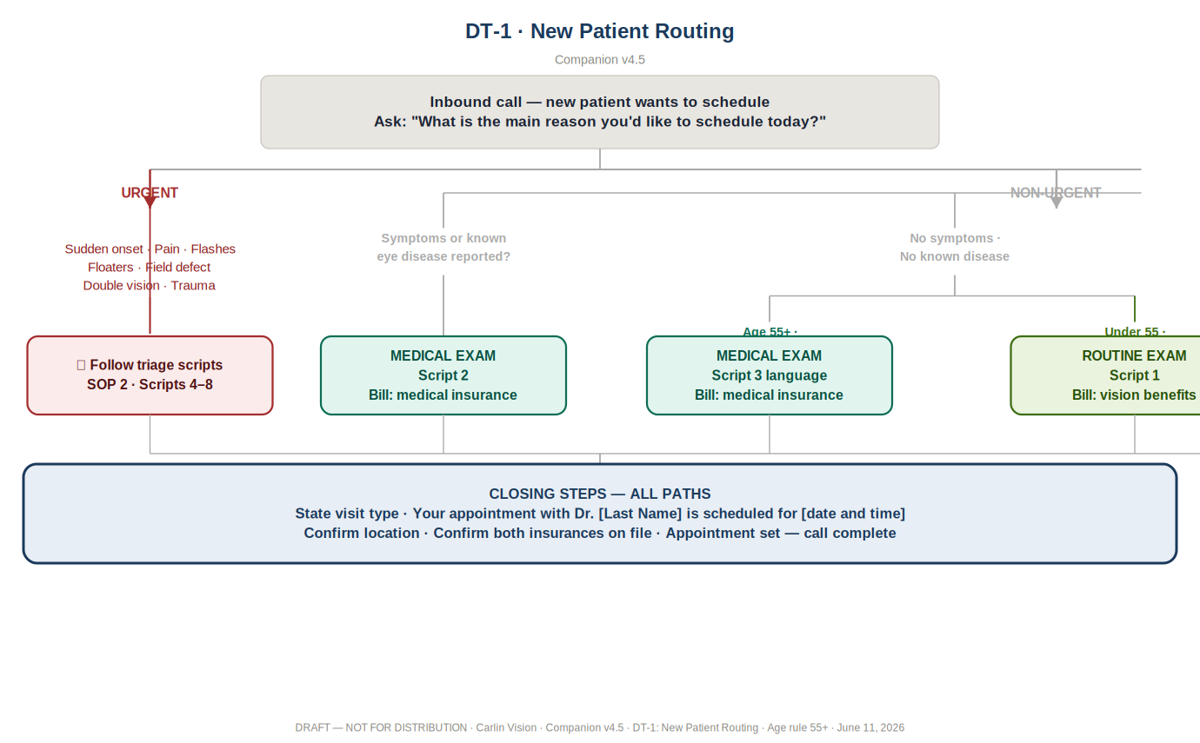
Logic summary: Inbound new-patient call → ask the chief complaint ("What is the main reason you'd like to schedule today?") → screen for urgent symptoms (sudden onset · pain · flashes · floaters · field defect · double vision · trauma). Urgent → Scripts 4–8. Non-urgent → symptoms or known eye disease reported → Medical (Script 2); no symptoms but age 55+ with blurred vision → Medical (Script 3 language); no symptoms and no blur criteria → Routine (Script 1). All paths close by stating the visit type, confirming the doctor and both insurances on file, and setting the appointment.

DT-2 — Returning Patient Routing
Scripts 1 · 2 · 3. Two parallel triggers at the same level. Age rule 55+ confirmed Dr. Carlin, June 11, 2026.
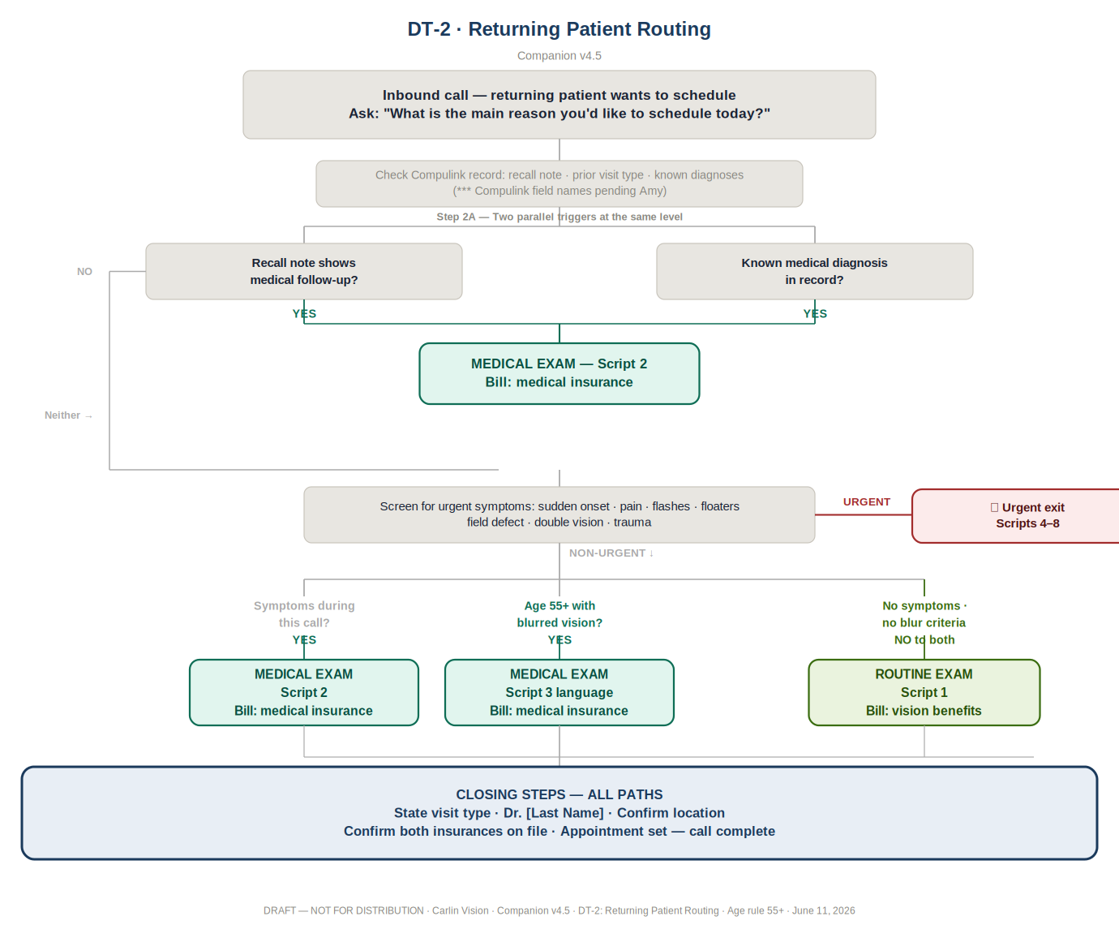
Logic summary: Inbound returning-patient call → ask the chief complaint and check the Compulink record (recall note · prior visit type · known diagnoses; field names pending Amy). Two parallel triggers at the same level — a recall note showing medical follow-up, or a known medical diagnosis on record — route to Medical (Script 2). Otherwise, screen for urgent symptoms (urgent → Scripts 4–8). Non-urgent: symptoms during this call → Medical (Script 2); age 55+ with blurred vision → Medical (Script 3 language); no symptoms and no blur criteria → Routine. All paths close by stating the visit type, confirming the doctor and both insurances on file, and setting the appointment.

DT-3 — Blurred Vision Decision Tree
Script 3 (Age 55+ Redirect). Age-55 blur rule confirmed Dr. Carlin, June 11, 2026.
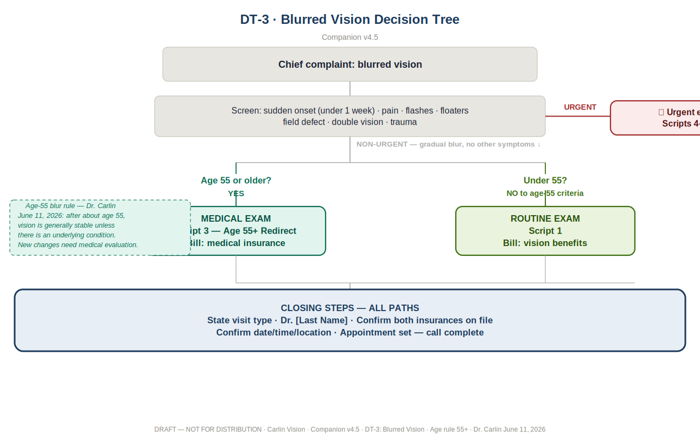
Logic summary: Chief complaint is blurred vision → screen for sudden onset (under 1 week), pain, flashes, floaters, field defect, double vision, or trauma. Any present → urgent (Scripts 4–8, billed to medical insurance). Non-urgent gradual blur with no other symptoms → age 55 or older → Medical eye exam using Script 3 age-55 redirect language; under 55 → Routine exam. All paths close by stating the visit type, confirming the doctor and both insurances on file, and setting the appointment.

DT-4 — Routine → Medical Conversion (In-Office)
Scripts 13 · 17 · 19 (refusal documentation per Script 16). Front desk comes to the patient in the exam room. Confirmed Dr. Carlin, May 14, 2026.
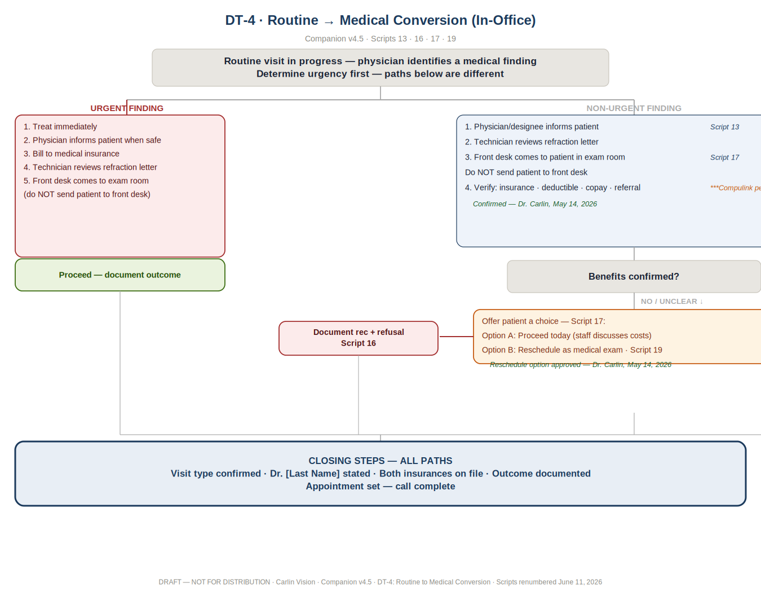
Logic summary: A routine visit is in progress and the physician identifies a medical finding → determine urgency (the two paths differ). Urgent finding: treat immediately, inform the patient when safe, bill to medical insurance, technician reviews the refraction letter, and the front desk comes to the exam room (Script 13). Non-urgent finding: physician or designee informs the patient (Script 13), technician reviews the refraction letter, and the front desk comes to the patient in the exam room to verify benefits — deductible, copay, referral (do not send the patient to the front desk; Script 17). If benefits are confirmed, proceed and document the outcome. If unclear, offer the patient a choice (Script 17): Option A — proceed today after staff discuss costs; Option B — reschedule as a medical exam (Script 19). Refusals are documented (Script 16). All paths close by confirming the visit type, the doctor, both insurances on file, and the documented outcome.

SECTION 3 — ALIGNMENT NOTES
This internal appendix summarizes how the SOPs and Decision Trees were harmonized with the locked Scripts 1–19. It is a record for the review team; it is not patient-facing. Where any conflict existed, it was resolved in favor of the locked scripts.
Major corrections made
Area | What was changed | Why
Doctor-selection order | SOP 1 call-flow (former §7 and §8) placed doctor selection before the chief complaint. Rebuilt so doctor selection follows the Step 5 routing decision, within the numbered script. | Locked scripts run: greeting → patient type/name/DOB → chief complaint → screening → route → then doctor selection (Step 2 of each script).
Universal call flow | SOP call sequence restated as Universal Opening Steps 1–5, then a separate in-script step table (confirm visit type, doctor, demographics, insurance, close). | Matches the Universal Call Opening and the per-script step numbering in the locked scripts.
Age-55 blur rule | Confirmed 55+ throughout; retained the June 11, 2026 confirmation box; tied the redirect explicitly to Script 3 / Script 12 language. | Scripts route age 55+ with blurred vision to a medical exam using Script 3 wording.
Known-diagnosis rule | Kept SOP 1 §5.4 and cross-referenced Script 10: a returning patient with a managed condition is medical even when requesting glasses or a routine check. | Mirrors Script 10 (returning patient with known diagnosis).
Insurance placement & wording | Insurance stated as collected after classification, doctor selection, and demographics. Added the wording standard: "routine vision benefit if you have any" in collection blocks; "routine vision benefits" in pushback/explanation lines. | Matches script step order and the locked routine-vision-benefit wording standard (no overpromising).
Triage categories & timing | SOP 2 categories mapped one-to-one to Scripts 4–8; timing grid preserved, including ASAP overrides, enlarged pupil = Today always, and swollen eyelid with pain = Today standalone. | Matches the triage logic and Today/ASAP triggers in Scripts 4–8.
In-office conversion | SOP 1 §6.2 and DT-4 aligned to Scripts 13, 17, and 19: front desk comes to the exam room, refraction letter reviewed, urgent care never delayed, non-urgent requires benefits verification, reschedule option available. | Mirrors Scripts 13, 17, and 19.
Refusal documentation | Refusal handling aligned to Scripts 15 and 16: returning patients documented in the scheduling comment box; new patients no record required. | Matches Scripts 15 and 16 and the triage refusal lines.
Decision-tree references | DT-4 script references clarified — conversion workflow is Scripts 13/17/19, with Script 16 noted specifically as refusal documentation. Diagrams retained as Dr. Carlin sketched them. | Removes ambiguity between conversion steps and refusal documentation.
Items intentionally left to the practice (not invented here)
- The detailed operational protocol for non-urgent benefits verification will be finalized by Amy and Dr. Carlin during rollout, once conversion volume is tracked. This document states the principle only, matching the scripts.
- Compulink recall/diagnosis field names are marked pending Amy, consistent with the decision-tree notes.
- Portal URL confirmation (About → Forms path) remains as written in the scripts; any URL change is Amy's to confirm.
Verification performed against the locked scripts
- Age-55 blur logic — matches (SOP 1 §5.2, DT-3; Scripts 3 and 12).
- Routine vs. medical rules — match (SOP 1 §3, §5.1; Scripts 1, 2, 11).
- Known-diagnosis handling — matches (SOP 1 §5.4; Script 10).
- Insurance collection placement and wording — match (SOP 1 §4, §7; Scripts 1–3 Step 4, Script 10).
- Triage categories and urgency timing — match (SOP 2 §5–§6; Scripts 4–8).
- In-office conversion workflow — matches (SOP 1 §6.2, DT-4; Scripts 13, 17, 19).
- SOP and Decision Trees do not contradict each other — confirmed.

